The Importance of Big O Notation in Machine Learning

[[Everton Gomede, PhD](https://medium.com/@evertongomede?source=post_page-----3e5243cfcab6--------------------------------)](https://medium.com/@evertongomede?source=post_page-----3e5243cfcab6--------------------------------)

[[The Modern Scientist](https://medium.com/the-modern-scientist?source=post_page-----3e5243cfcab6--------------------------------)](https://medium.com/the-modern-scientist?source=post_page-----3e5243cfcab6--------------------------------)

[Everton Gomede, PhD](https://medium.com/@evertongomede?source=post_page-----3e5243cfcab6--------------------------------)

·

[Follow](https://medium.com/m/signin?actionUrl=https%3A%2F%2Fmedium.com%2F_%2Fsubscribe%2Fuser%2Fb1a64eb107f0&operation=register&redirect=https%3A%2F%2Fmedium.com%2Fthe-modern-scientist%2Fthe-importance-of-big-o-notation-in-machine-learning-3e5243cfcab6&user=Everton+Gomede%2C+PhD&userId=b1a64eb107f0&source=post_page-b1a64eb107f0----3e5243cfcab6---------------------post_header-----------)

Published in

[The Modern Scientist](https://medium.com/the-modern-scientist?source=post_page-----3e5243cfcab6--------------------------------)

·

4 min read

·

Dec 13, 2023

16

**Introduction**

In the ever-evolving field of machine learning, the efficiency of algorithms is paramount. Big O notation emerges as a critical tool in this regard, offering a language to describe the performance or complexity of an algorithm, particularly in terms of time and space. This essay explores the significance of Big O notation in machine learning, elucidating its role in algorithm selection, optimization, and overall system design.

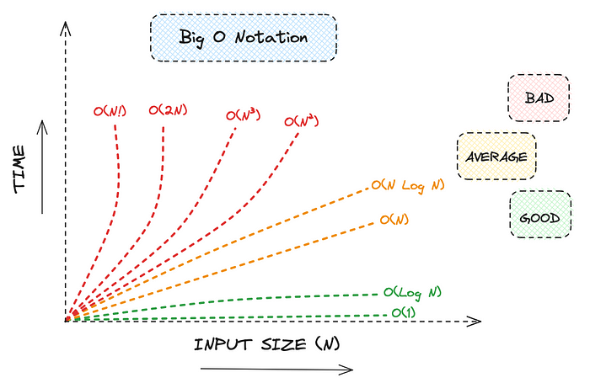

*In the realm of machine learning, understanding Big O notation is not just about measuring complexity; it’s about unlocking efficiency, scalability, and the potential to turn data into wisdom.*

**Understanding Big O Notation**

Big O notation characterizes functions based on their growth rates. It is crucial in algorithm analysis, providing a high-level understanding of the algorithm’s behavior in terms of input size. Common Big O notations include O(1) for constant time, O(n) for linear time, O(log n) for logarithmic time, and more complex forms like O(n²) for quadratic time and O(2^n) for exponential time.

**The Role of Big O in Machine Learning**

**Algorithm Selection**

In machine learning, selecting the right algorithm is essential for effective model training and prediction. Big O notation aids in this selection process by providing insights into the time and space complexity of algorithms. For instance, an algorithm with O(n²) complexity may be feasible for small datasets but becomes impractical for larger ones. Understanding these complexities helps in choosing the most efficient algorithm for a given data size and problem type.

**Optimization of Models**

Machine learning involves dealing with large datasets and complex models. The optimization of these models is crucial for enhancing performance and reducing computational costs. Big O notation assists in identifying bottlenecks in algorithms, guiding developers towards more efficient implementations. For example, reducing the complexity from O(n²) to O(n log n) can significantly speed up a model’s training time.

**Scalability and Real-world Applications**

The scalability of machine learning models is a vital concern, especially for applications in real-world scenarios where data volume can be immense. Big O notation provides a framework to evaluate and ensure the scalability of algorithms. Algorithms with lower complexity are more scalable and better suited for large-scale applications, such as real-time data analysis and high-frequency trading systems.

**Time-Space Trade-off**

Big O notation also illuminates the time-space trade-off in algorithm design. Some algorithms may be fast (having a lower time complexity) but consume more memory (higher space complexity), and vice versa. Understanding this trade-off is crucial in machine learning, where both time and memory resources can be limiting factors.

**Challenges and Considerations**

While Big O notation is a powerful tool, it’s not without limitations. It provides an asymptotic analysis, which might not always accurately reflect real-world performance. Additionally, it doesn’t account for factors like hardware efficiency, parallel computing capabilities, and data structure choice, which can significantly impact the actual performance of machine learning algorithms.

**Code**

Creating a complete Python example that demonstrates the application of Big O notation in machine learning involves several steps. We will:

1. Generate a synthetic dataset.
2. Implement machine learning algorithms with varying complexities.
3. Measure and plot the performance of these algorithms in relation to the size of the dataset to illustrate their Big O complexities.

**Step 1: Generate a Synthetic Dataset**

We will use sklearn.datasets.make_regression to create a synthetic dataset for regression problems. This function allows us to control the number of samples, which is crucial for analyzing the performance of algorithms at different dataset sizes.

**Step 2: Implement Machine Learning Algorithms**

We’ll focus on two algorithms:

* Linear Regression (O(n)): Typically linear or near-linear in complexity.
* K-Nearest Neighbors (KNN) (O(n²)): Generally quadratic in complexity for brute-force implementations.

**Step 3: Measure and Plot Performance**

We’ll measure the time it takes to train these models on datasets of varying sizes and plot these times to visualize the Big O complexities.

Let’s write the code:

import numpy as np  
import matplotlib.pyplot as plt  
import time  
from sklearn.linear_model import LinearRegression  
from sklearn.neighbors import KNeighborsRegressor  
from sklearn.datasets import make_regression  
  
# Initialize the range of dataset sizes and an empty list to store performance metrics  
dataset_sizes = np.linspace(100, 1000, 10, dtype=int)  
linear_regression_times = []  
knn_times = []  
  
for size in dataset_sizes:  
 # Generate a synthetic dataset  
 X, y = make_regression(n_samples=size, n_features=5, noise=0.1)  
   
 # Measure performance for Linear Regression  
 start_time = time.time()  
 linear_model = LinearRegression().fit(X, y)  
 linear_regression_times.append(time.time() - start_time)  
  
 # Measure performance for K-Nearest Neighbors  
 start_time = time.time()  
 knn_model = KNeighborsRegressor().fit(X, y)  
 knn_times.append(time.time() - start_time)  
  
# Plotting the results  
plt.figure(figsize=(10, 6))  
plt.plot(dataset_sizes, linear_regression_times, label='Linear Regression (O(n))')  
plt.plot(dataset_sizes, knn_times, label='KNN (O(n^2))')  
plt.xlabel('Dataset Size')  
plt.ylabel('Training Time (seconds)')  
plt.title('Algorithm Complexity Analysis using Big O Notation')  
plt.legend()  
plt.show()

This script will produce a plot showing how the training time of each algorithm scales with the size of the dataset. The linear regression line should show a near-linear increase in training time with the dataset size, reflecting its O(n) complexity. In contrast, the KNN line should show a more rapid increase in training time, reflecting its higher complexity, typically O(n²) for brute-force implementations.

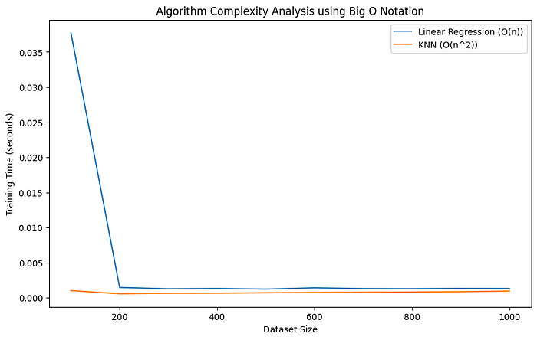

**Conclusion**

Big O notation plays a fundamental role in the field of machine learning. It aids in the selection, optimization, and scalability assessment of algorithms. While it’s an abstraction that may not capture all aspects of an algorithm’s performance, its importance in guiding developers towards efficient and effective machine learning solutions cannot be overstated. As machine learning continues to grow and evolve, the relevance of Big O notation in navigating this complex landscape remains undiminished.

[Artficial Intelligence](https://medium.com/tag/artficial-intelligence?source=post_page-----3e5243cfcab6---------------artficial_intelligence-----------------)

[Machine Learning](https://medium.com/tag/machine-learning?source=post_page-----3e5243cfcab6---------------machine_learning-----------------)

[Deep Learning](https://medium.com/tag/deep-learning?source=post_page-----3e5243cfcab6---------------deep_learning-----------------)

[Data Science](https://medium.com/tag/data-science?source=post_page-----3e5243cfcab6---------------data_science-----------------)

[Algorithms](https://medium.com/tag/algorithms?source=post_page-----3e5243cfcab6---------------algorithms-----------------)